- Data Types
- C# supports several types of predefined data types. You can observe them in the following diagram.
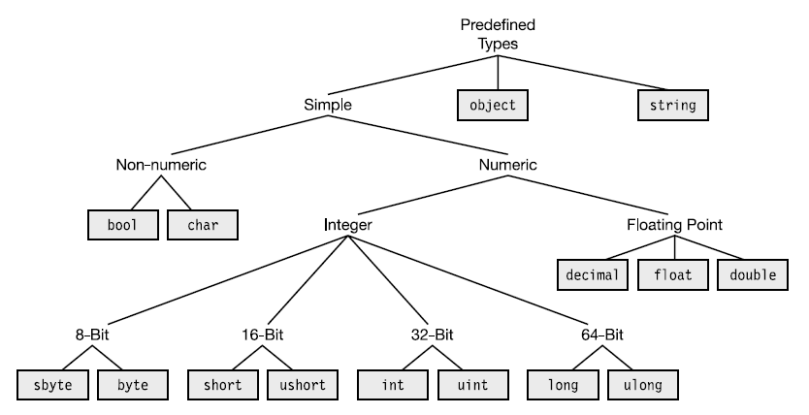
You can observe the data types, memory size and ranges in the following table.
Data Type | Description | Range | Bytes
sbyte | 8-bit signed integer | -128 to 127 | 1
byte | 8-bit unsigned integer | 0 to 255 | 1
short | 16-bit signed integer | -32,768 to 32,767 | 2
ushort | 16-bit unsigned integer | 0 to 65,535 | 2
Int | 32-bit signed integer | -2,147,483,648 to 2,147,483,647 | 4
uint | 32-bit unsigned integer | 0 to 4,294,967,295 | 4
long | 64-bit signed integer | -9,223,372,036,854,775,808 to  9,223,372,036,854,775,807 | 8
ulong | 64-bit unsigned integer | 0 to 18,446,744,073,709,551,615 | 8
float | Single-precision float | 1.5×10⁻⁴⁵ to 3.4×10³⁸ | 4
double | Double-precision float | 5×10⁻³²⁴ to 1.7×10³⁰⁸ | 8
decimal | Decimal value with  28-significant-digit  precision | ±1.0×10^{28 to} ±7.9×10²⁸ | 16
bool | Boolean | true, false | 1
char | Unicode character | Any one character | 2
object | Any type of value | ---- | Based on the value
string | Group of characters | 2 billion characters | No. of chars X 2  (Initially 0)

- Variables
- Variable declaration:
Syn: datatype variable;
Ex: int x;
- Variable declaration along with initialization:
Syn: datatype variable=value;
Ex: int x=10;
- Multiple Variable declaration:
Syn: datatype variable1,variable2,variable3,…;
Ex: int x,y,z;

Note: When we declare any variable, it should be assigned to a value before its usage. Otherwise, it causes a compile time error.
Note: “+” is known as “concatenation” operator, which can concatenate two similar or different types of values as a “string”.
Application 3: Demo on Variables
using System;
using System.Collections.Generic;
using System.Linq;
using System.Text;

namespace Variables
{
class Program
{
static void Main(string[] args)
{
int n = 4561;
Console.WriteLine(n);
decimal a, b, c;
double d1, d2=45.123, d3;
Console.WriteLine("d2 value is " + d2);
string s1;
bool b1 = true;
Console.WriteLine(b1);
string Country = "India";
int States = 28;
Console.WriteLine("Our country is " + Country + ". It has " + States + " states.");
Console.Read();
}
}
}

Output: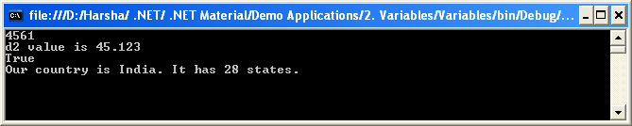

- Escape Sequence Characters
Escape Sequence | Description | Actual Character
\’ | Single quotation mark | ‘
\” | Double quotation mark | “
\\ | Backslash | \
\0 | Null | Null
\b | Backspace | Backspace
\n | New line | New line
\t | Tab | Tab
Application 4: Demo on Escape Sequence Characters

using System;
using System.Collections.Generic;
using System.Linq;
using System.Text;

namespace EscapeSequenceCharacters
{
class Program
{
static void Main(string[] args)
{
Console.WriteLine("This is first line\nThis is second line\nThis is third line.");
Console.WriteLine("\'C#\' has derived from \"C\" and \"C++\".");
Console.WriteLine("The escape sequence character \\n is used to insert new line.");
Console.WriteLine("One\tTwo\tThree");
Console.WriteLine("An\bt");
Console.Read();
}
}
}

Output:
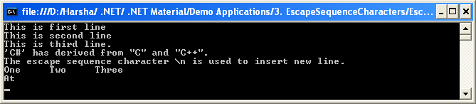
- Type casting
Def: The process of converting the value from one data type to another data type is called as “Casting”.
This is of two types.
- Implicit Casting:
The value can be converted by the compiler automatically, without using any extra statement.
- Explicit Casting:
The value can be converted by the programmer using a conversion method.

Implicit Casting
Implicit casting is possible in the following cases.
- Any numerical value from lower to higher type.
Ex: byte to short
short to int
float to double
etc.
- Any numerical value from non-decimal type to decimal type.
Ex: int to float
long to double
etc.
The following table shows the all possible implicit conversion supported by C#.

Implicit Casting in C#:
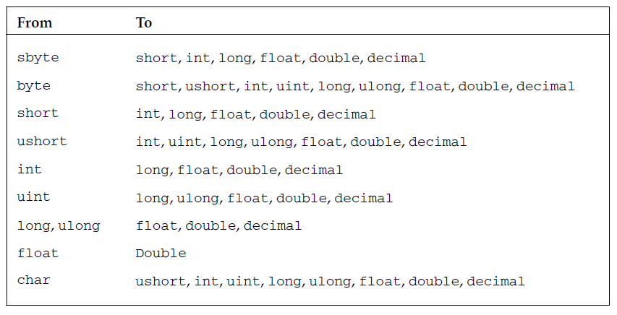

Explicit Casting
Explicit casting should be performed in the following cases:
- Any numerical value from higher type to lower type.
- Any numerical value from decimal type to non-decimal type.
- Any value from numerical type to non-numerical type.
- Any value from non-numerical type to numerical type.
Syn: (target data type)variable
(target data type)value
Application 5: Demo on Casting

using System;
using System.Collections.Generic;
using System.Linq;
using System.Text;

namespace Casting
{
class Program
{
static void Main(string[] args)
{

int x = 10;
long y = x; //implicit
byte z = (byte)x; //explicit
double p = x; //implicit
int q = (int)p; //explicit
Console.WriteLine(x);
Console.WriteLine(y);
Console.WriteLine(z);
Console.WriteLine(p);
Console.WriteLine(q);
Console.Read();
}
}
}

Output: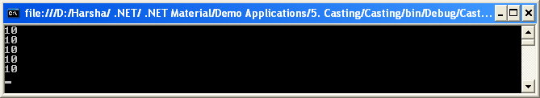

Explicit Casting using Conversion Methods
Explicit casting can also be performed by using the “Conversion methods”. The “System.Convert” class provides several methods to perform explicit casting.
- System.Convert.ToSByte(value);
Converts the value into “sbyte” type.
- System.Convert.ToByte(value);
Converts the value into “byte” type.
- System.Convert.ToInt16(value);
Converts the value into “short” type.
- System.Convert.ToUInt16(value);
Converts the value into “ushort” type.
- System.Convert.ToInt32(value);
Converts the value into “int” type.
- System.Convert.ToUInt32(value);
Converts the value into “uint” type.
- System.Convert.ToInt64(value);
Converts the value into “long” type.
- System.Convert.ToUInt64(value);
Converts the value into “ulong” type.
- System.Convert.ToSingle(value);
Converts the value into “float” type.
- System.Convert.ToDouble(value);
Converts the value into “double” type.
- System.Convert.ToChar(value);
Converts the value into “char” type.
- System.Convert.ToString(value);
Converts the value into “string” type.
- System.Convert.ToBoolean(value);
Converts the value into “bool” type.
Application 6: Demo on Casting with Conversion Methods

using System;
using System.Collections.Generic;
using System.Linq;
using System.Text;

namespace ConversionMethods
{
class Program
{
static void Main(string[] args)
{
int x = 10;
long y = x; //implicit
byte z = Convert.ToByte(x); //explicit
double p = x; //implicit
int q = Convert.ToInt32(p); //explicit
Console.WriteLine(x);

Console.WriteLine(y);
Console.WriteLine(z);
Console.WriteLine(p);
Console.WriteLine(q);
char c = 'A';
string s = Convert.ToString(c); //explicit
Console.WriteLine(s);
Console.Read();
}
}
}

Output:
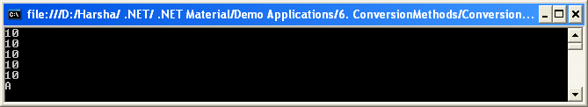

IMP Note:
- By default, C# recognizes all the integer constants as the type of “int”.
- In the same way, C# recognizes all the floating point constants as the type of “double”.

